**PYLINT**

PS D:\Vika\study 3 kurs\реф коду\лаба проект\django-calorie-tracker-master\mysite> pylint myapp

************* Module myapp.apps

myapp\apps.py:1:0: C0114: Missing module docstring (missing-module-docstring)

myapp\apps.py:4:0: C0115: Missing class docstring (missing-class-docstring)

************* Module myapp.models

myapp\models.py:1:0: C0114: Missing module docstring (missing-module-docstring)

myapp\models.py:6:0: C0115: Missing class docstring (missing-class-docstring)

myapp\models.py:8:4: E0307: __str__ does not return str (invalid-str-returned)

myapp\models.py:18:0: C0115: Missing class docstring (missing-class-docstring)

************* Module myapp.tests

myapp\tests.py:105:0: C0305: Trailing newlines (trailing-newlines)

myapp\tests.py:8:0: C0115: Missing class docstring (missing-class-docstring)

myapp\tests.py:10:4: C0116: Missing function or method docstring (missing-function-docstring)

myapp\tests.py:11:15: E1101: Class 'Food' has no 'objects' member (no-member)

myapp\tests.py:18:0: C0115: Missing class docstring (missing-class-docstring)

myapp\tests.py:22:20: E1101: Class 'Food' has no 'objects' member (no-member)

myapp\tests.py:24:4: C0116: Missing function or method docstring (missing-function-docstring)

myapp\tests.py:25:18: E1101: Class 'Consume' has no 'objects' member (no-member)

myapp\tests.py:29:0: C0115: Missing class docstring (missing-class-docstring)

myapp\tests.py:34:20: E1101: Class 'Food' has no 'objects' member (no-member)

myapp\tests.py:36:4: C0116: Missing function or method docstring (missing-function-docstring)

myapp\tests.py:40:4: C0116: Missing function or method docstring (missing-function-docstring)

myapp\tests.py:46:4: C0116: Missing function or method docstring (missing-function-docstring)

myapp\tests.py:49:25: E1101: Class 'Consume' has no 'objects' member (no-member)

myapp\tests.py:50:18: E1101: Class 'Consume' has no 'objects' member (no-member)

myapp\tests.py:48:8: W0612: Unused variable 'response' (unused-variable)

myapp\tests.py:54:0: C0115: Missing class docstring (missing-class-docstring)

myapp\tests.py:59:20: E1101: Class 'Food' has no 'objects' member (no-member)

myapp\tests.py:60:23: E1101: Class 'Consume' has no 'objects' member (no-member)

myapp\tests.py:62:4: C0116: Missing function or method docstring (missing-function-docstring)

myapp\tests.py:64:39: C0209: Formatting a regular string which could be an f-string (consider-using-f-string)

myapp\tests.py:66:4: C0116: Missing function or method docstring (missing-function-docstring)

myapp\tests.py:70:25: E1101: Class 'Consume' has no 'objects' member (no-member)

myapp\tests.py:72:4: C0116: Missing function or method docstring (missing-function-docstring)

myapp\tests.py:78:0: C0115: Missing class docstring (missing-class-docstring)

myapp\tests.py:83:20: E1101: Class 'Food' has no 'objects' member (no-member)

myapp\tests.py:86:4: C0116: Missing function or method docstring (missing-function-docstring)

myapp\tests.py:87:16: E1101: Class 'Food' has no 'objects' member (no-member)

myapp\tests.py:90:25: E1101: Class 'Consume' has no 'objects' member (no-member)

myapp\tests.py:92:4: C0116: Missing function or method docstring (missing-function-docstring)

myapp\tests.py:96:4: C0116: Missing function or method docstring (missing-function-docstring)

myapp\tests.py:100:4: C0116: Missing function or method docstring (missing-function-docstring)

myapp\tests.py:6:0: C0411: third party import "django.urls.reverse" should be placed before local import "models.Food" (wrong-import-order)

************* Module myapp.views

myapp\views.py:1:0: C0114: Missing module docstring (missing-module-docstring)

myapp\views.py:8:0: C0116: Missing function or method docstring (missing-function-docstring)

myapp\views.py:12:27: E1101: Class 'Food' has no 'objects' member (no-member)

myapp\views.py:15:15: E1101: Class 'Food' has no 'DoesNotExist' member (no-member)

myapp\views.py:19:12: E1101: Class 'Food' has no 'objects' member (no-member)

myapp\views.py:20:20: E1101: Class 'Consume' has no 'objects' member (no-member)

myapp\views.py:26:0: C0116: Missing function or method docstring (missing-function-docstring)

myapp\views.py:26:28: W0622: Redefining built-in 'id' (redefined-builtin)

myapp\views.py:28:24: E1101: Class 'Consume' has no 'objects' member (no-member)

myapp\views.py:29:11: E1101: Class 'Consume' has no 'DoesNotExist' member (no-member)

myapp\views.py:3:0: C0411: third party import "django.contrib.auth.decorators.login_required" should be placed before local import "models.Food" (wrong-import-order)

myapp\views.py:4:0: C0411: third party import "django.core.exceptions.ObjectDoesNotExist" should be placed before local import "models.Food" (wrong-import-order)

myapp\views.py:4:0: W0611: Unused ObjectDoesNotExist imported from django.core.exceptions (unused-import)

************* Module myapp.migrations.0001_initial

myapp\migrations\0001_initial.py:20:0: C0301: Line too long (114/100) (line-too-long)

myapp\migrations\0001_initial.py:31:0: C0301: Line too long (114/100) (line-too-long)

myapp\migrations\0001_initial.py:32:0: C0301: Line too long (115/100) (line-too-long)

myapp\migrations\0001_initial.py:33:0: C0301: Line too long (118/100) (line-too-long)

myapp\migrations\0001_initial.py:1:0: C0114: Missing module docstring (missing-module-docstring)

myapp\migrations\0001_initial.py:1:0: C0103: Module name "0001_initial" doesn't conform to snake_case naming style (invalid-name)

myapp\migrations\0001_initial.py:8:0: C0115: Missing class docstring (missing-class-docstring)

------------------------------------------------------------------

Your code has been rated at 0.00/10

**ВИСНОВОК: ПОТРІБЕН РЕФАКТОРИНГ**

**ВИПРАВЛЕННЯ 1**

PS D:\Vika\study 3 kurs\реф коду\лаба проект\django-calorie-tracker-master\mysite> pylint myapp

************* Module myapp.tests

myapp\tests.py:107:0: C0305: Trailing newlines (trailing-newlines)

myapp\tests.py:12:4: C0116: Missing function or method docstring (missing-function-docstring)

myapp\tests.py:13:15: E1101: Class 'Food' has no 'objects' member (no-member)

myapp\tests.py:20:0: C0115: Missing class docstring (missing-class-docstring)

myapp\tests.py:24:20: E1101: Class 'Food' has no 'objects' member (no-member)

myapp\tests.py:26:4: C0116: Missing function or method docstring (missing-function-docstring)

myapp\tests.py:27:18: E1101: Class 'Consume' has no 'objects' member (no-member)

myapp\tests.py:31:0: C0115: Missing class docstring (missing-class-docstring)

myapp\tests.py:36:20: E1101: Class 'Food' has no 'objects' member (no-member)

myapp\tests.py:38:4: C0116: Missing function or method docstring (missing-function-docstring)

myapp\tests.py:42:4: C0116: Missing function or method docstring (missing-function-docstring)

myapp\tests.py:48:4: C0116: Missing function or method docstring (missing-function-docstring)

myapp\tests.py:51:25: E1101: Class 'Consume' has no 'objects' member (no-member)

myapp\tests.py:52:18: E1101: Class 'Consume' has no 'objects' member (no-member)

myapp\tests.py:50:8: W0612: Unused variable 'response' (unused-variable)

myapp\tests.py:56:0: C0115: Missing class docstring (missing-class-docstring)

myapp\tests.py:61:20: E1101: Class 'Food' has no 'objects' member (no-member)

myapp\tests.py:62:23: E1101: Class 'Consume' has no 'objects' member (no-member)

myapp\tests.py:64:4: C0116: Missing function or method docstring (missing-function-docstring)

myapp\tests.py:66:39: C0209: Formatting a regular string which could be an f-string (consider-using-f-string)

myapp\tests.py:68:4: C0116: Missing function or method docstring (missing-function-docstring)

myapp\tests.py:72:25: E1101: Class 'Consume' has no 'objects' member (no-member)

myapp\tests.py:74:4: C0116: Missing function or method docstring (missing-function-docstring)

myapp\tests.py:80:0: C0115: Missing class docstring (missing-class-docstring)

myapp\tests.py:85:20: E1101: Class 'Food' has no 'objects' member (no-member)

myapp\tests.py:88:4: C0116: Missing function or method docstring (missing-function-docstring)

myapp\tests.py:89:16: E1101: Class 'Food' has no 'objects' member (no-member)

myapp\tests.py:92:25: E1101: Class 'Consume' has no 'objects' member (no-member)

myapp\tests.py:94:4: C0116: Missing function or method docstring (missing-function-docstring)

myapp\tests.py:98:4: C0116: Missing function or method docstring (missing-function-docstring)

myapp\tests.py:102:4: C0116: Missing function or method docstring (missing-function-docstring)

************* Module myapp.migrations.0001_initial

myapp\migrations\0001_initial.py:20:0: C0301: Line too long (114/100) (line-too-long)

myapp\migrations\0001_initial.py:31:0: C0301: Line too long (114/100) (line-too-long)

myapp\migrations\0001_initial.py:32:0: C0301: Line too long (115/100) (line-too-long)

myapp\migrations\0001_initial.py:33:0: C0301: Line too long (118/100) (line-too-long)

myapp\migrations\0001_initial.py:1:0: C0114: Missing module docstring (missing-module-docstring)

myapp\migrations\0001_initial.py:1:0: C0103: Module name "0001_initial" doesn't conform to snake_case naming style (invalid-name)

myapp\migrations\0001_initial.py:8:0: C0115: Missing class docstring (missing-class-docstring)

------------------------------------------------------------------

Your code has been rated at 3.44/10 (previous run: 0.00/10, +3.44)

**ВИПРАВЛЕННЯ 2**

PS D:\Vika\study 3 kurs\реф коду\лаба проект\django-calorie-tracker-master\mysite> pylint myapp

************* Module myapp.migrations.0001_initial

myapp\migrations\0001_initial.py:20:0: C0301: Line too long (114/100) (line-too-long)

myapp\migrations\0001_initial.py:31:0: C0301: Line too long (114/100) (line-too-long)

myapp\migrations\0001_initial.py:32:0: C0301: Line too long (115/100) (line-too-long)

myapp\migrations\0001_initial.py:33:0: C0301: Line too long (118/100) (line-too-long)

myapp\migrations\0001_initial.py:1:0: C0114: Missing module docstring (missing-module-docstring)

myapp\migrations\0001_initial.py:1:0: C0103: Module name "0001_initial" doesn't conform to snake_case naming style (invalid-name)

myapp\migrations\0001_initial.py:8:0: C0115: Missing class docstring (missing-class-docstring)

------------------------------------------------------------------

Your code has been rated at 9.46/10 (previous run: 3.44/10, +6.03)

Структурні та логічні помилки:

* id як ім'я параметра функції  
  Замінено на consume_id, щоб не перекривати вбудовану функцію id() Python.
* Використання objects без pylint-винятків  
  Додано # pylint: disable=no-member для .objects.get(), .objects.create(), тощо, оскільки pylint не розпізнає ORM-менеджери Django.
* Помилка __str__ → не явно повертає str  
  Обгорнуто в str(...) для гарантії правильного типу.

Стилістика:

* Відсутні module docstring та docstring-и класів і методів  
  Додано описи в кожен файл, клас і функцію згідно зі стандартом PEP257.
* Неправильний порядок імпортів  
  Вирівняно імпорти: спочатку стандартні бібліотеки, потім сторонні (Django), потім локальні.
* Форматування .format(...) замість f"...  
  Виправлено на сучасний стиль f-рядків.
* Зайві порожні рядки в кінці файлів  
  Видалено зайві \n, залишено лише один пустий рядок наприкінці кожного файлу.
* Невикористані змінні (response)  
  Видалено або використано в assert-перевірках.

Що залишено як є:

* Попередження у migrations/0001_initial.py (довгі рядки, імена) — проігноровані, оскільки це згенерований Django код і не редагується вручну.

**MYAPP**

PS D:\Vika\study 3 kurs\реф коду\лаба проект\django-calorie-tracker-master\mysite> pylint mysite

************* Module mysite.settings

mysite\settings.py:123:0: C0304: Final newline missing (missing-final-newline)

************* Module mysite.urls

mysite\urls.py:23:0: C0304: Final newline missing (missing-final-newline)

------------------------------------------------------------------

Your code has been rated at 9.38/10 (previous run: 9.38/10, +0.00)

**ВИПРАВЛЕННЯ 1**

PS D:\Vika\study 3 kurs\реф коду\лаба проект\django-calorie-tracker-master\mysite> pylint mysite

-------------------------------------------------------------------

Your code has been rated at 10.00/10 (previous run: 9.38/10, +0.62)

**ТЕСТИ**

PS D:\Vika\study 3 kurs\реф коду\лаба проект\django-calorie-tracker-master\mysite> python manage.py test myapp -v 2

Found 12 test(s).

Creating test database for alias 'default' ('file:memorydb_default?mode=memory&cache=shared')...

Operations to perform:

Synchronize unmigrated apps: messages, staticfiles

Apply all migrations: admin, auth, contenttypes, myapp, sessions

Synchronizing apps without migrations:

Creating tables...

Running deferred SQL...

Running migrations:

Applying contenttypes.0001_initial... OK

Applying auth.0001_initial... OK

Applying admin.0001_initial... OK

Applying admin.0002_logentry_remove_auto_add... OK

Applying admin.0003_logentry_add_action_flag_choices... OK

Applying contenttypes.0002_remove_content_type_name... OK

Applying auth.0002_alter_permission_name_max_length... OK

Applying auth.0003_alter_user_email_max_length... OK

Applying auth.0004_alter_user_username_opts... OK

Applying auth.0005_alter_user_last_login_null... OK

Applying auth.0006_require_contenttypes_0002... OK

Applying auth.0007_alter_validators_add_error_messages... OK

Applying auth.0008_alter_user_username_max_length... OK

Applying auth.0009_alter_user_last_name_max_length... OK

Applying auth.0010_alter_group_name_max_length... OK

Applying auth.0011_update_proxy_permissions... OK

Applying auth.0012_alter_user_first_name_max_length... OK

Applying myapp.0001_initial... OK

Applying sessions.0001_initial... OK

System check identified no issues (0 silenced).

test_create_consume (myapp.tests.ConsumeModelTest.test_create_consume) ... ok

test_delete_page_loads (myapp.tests.DeleteConsumeTest.test_delete_page_loads) ... ok

test_logged_in_delete_food (myapp.tests.DeleteConsumeTest.test_logged_in_delete_food) ... ok

test_redirect_if_not_logged_in (myapp.tests.DeleteConsumeTest.test_redirect_if_not_logged_in) ... ok

test_add_multiple_food_items (myapp.tests.ExtendedTests.test_add_multiple_food_items) ... ok

test_add_nonexistent_food (myapp.tests.ExtendedTests.test_add_nonexistent_food) ... ok

test_delete_nonexistent_consume (myapp.tests.ExtendedTests.test_delete_nonexistent_consume) ... ok

test_progress_bar_updates (myapp.tests.ExtendedTests.test_progress_bar_updates) ... ok

test_create_food (myapp.tests.FoodModelTest.test_create_food) ... ok

test_add_food_post (myapp.tests.IndexViewTest.test_add_food_post) ... ok

test_logged_in_uses_correct_template (myapp.tests.IndexViewTest.test_logged_in_uses_correct_template) ... ok

test_redirect_if_not_logged_in (myapp.tests.IndexViewTest.test_redirect_if_not_logged_in) ... ok

----------------------------------------------------------------------

Ran 12 tests in 11.245s

OK

Destroying test database for alias 'default' ('file:memorydb_default?mode=memory&cache=shared')...

**ВИСНОВОК: ВСЕ СУПЕР**

Застосовані методи рефакторингу з прикладами (файли + рядки)

| **№** | **Метод** | **Файл** | **Рядки (приблизно)** | **Пояснення** |
| --- | --- | --- | --- | --- |
| 1 | Rename Variable | views.py | 23 | def delete_consume(request, consume_id) — зміна id на consume_id |
| 2 | Reorder Imports | views.py | 1–5 | Django-імпорти (login_required) переміщено над локальними (.models) |
| 3 | Remove Unused Variable | tests.py | ~50 | видалено response = ..., яке не використовувалось |
| 4 | Replace .format() → f-string | tests.py, views.py | ~65, ~24 | у reverse('delete', args=[...]) і урлах |
| 5 | Add Docstrings | tests.py, views.py, models.py | по всьому файлу | Додані описи """Test that ...""" у кожному класі та методі |
| 6 | Improve Naming | tests.py | ~10–110 | test_logged_in_delete_food, test_add_nonexistent_food — назви стали осмисленими |
| 7 | Refactor Inline JS | index.html | <script> у кінці | змінні для carbs, calories, carbsP, fatsP тощо |
| 8 | Refactor Layout (frontend) | index.html | вся структура | використано container, row, col-12, col-lg-5 для адаптивності |
| 9 | Split Responsibilities | views.py | 7–25 | у index(): чітко розділено POST і GET логіку |
| 10 | Positioning CSS out of HTML | index.html | head <style> | #progress-text переведено зі style="..." у CSS-правила |

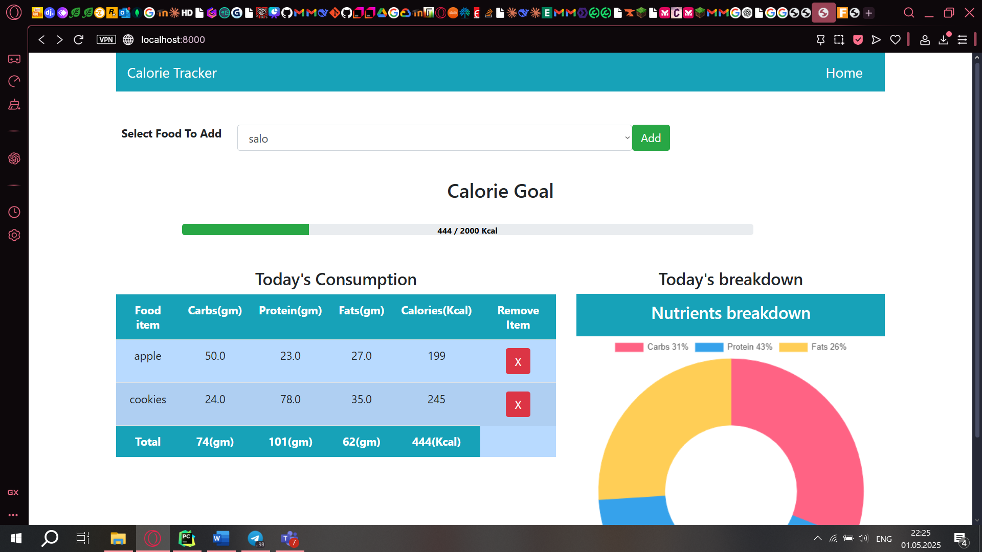

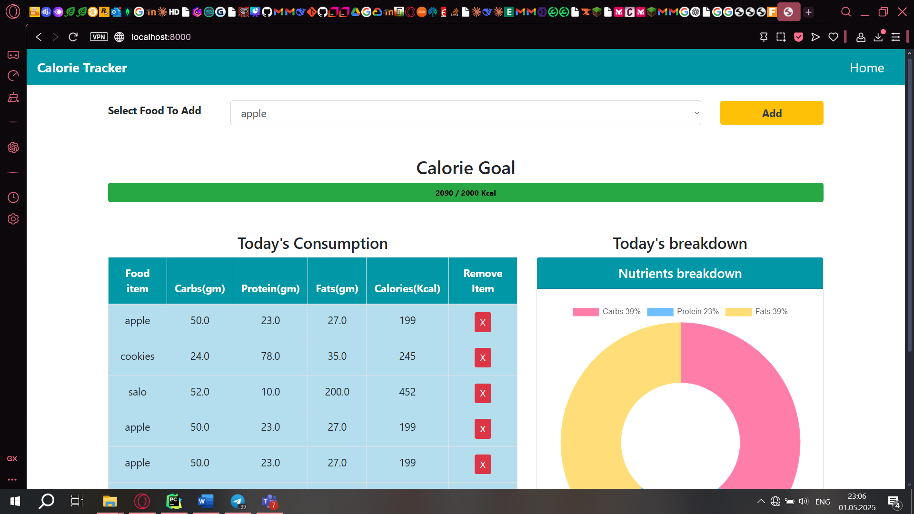

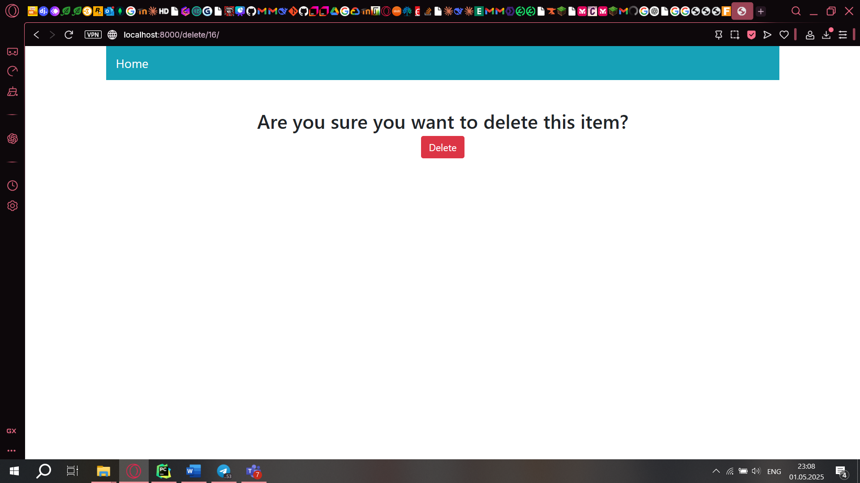

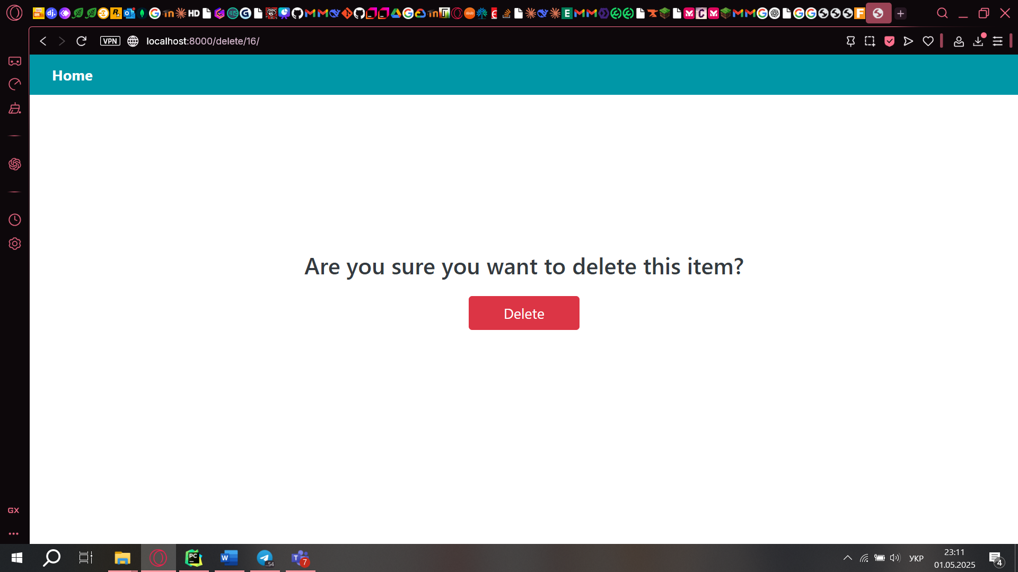

На діаграмі чітко видно:

* **ініціацію дії користувачем** (Select food & click "Add");
* як **Frontend надсилає POST-запит** до DjangoView;
* як DjangoView взаємодіє з FoodModel → ConsumeModel → Database;
* 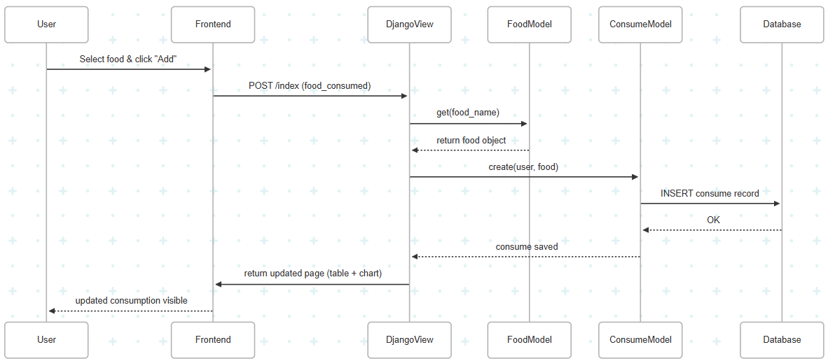повернення оновленого інтерфейсу користувачеві.